

SMAFIN Expanded National RT

Minutes of the third RT in Romania,
23 April 2026,
Romanian Banking Institute, Bucharest


www.smafin.eu
The SMAFIN Expanded project is co-funded by the European Union’s Programme for the Environment and Climate Action (LIFE) under grant agreement No 101120412
The third SMAFIN EXPANDED National Round Table (RT) in Romania was organised by the Romanian partners of the project: ROGBC – the Romanian Green Building Council (https://www.rogbc.org/) and pRO-nZEB – the Cluster for the Promotion of Nearly Zero-Energy Buildings (https://www.pro-nzeb.ro/).

This event built on the discussions held during previous events organised under the SMAFIN and SMAFIN EXPANDED projects, while also addressing new topics reflecting the significant developments that have occurred since the 2025 edition of the RT. It further explored emerging areas of interest aligned with the objectives of the SMAFIN EXPANDED project. The event was organised in accordance with the format developed under the project, and its agenda was prepared based on the recommendations and guidance of the members of the SMAFIN EXPANDED Working Group.

This edition of the RT addressed practical approaches to supporting the large-scale implementation of energy efficiency investment projects through the promotion of solutions, financial instruments, and innovative financing schemes that deliver measurable impact, attract additional private investment, and offer significant replication potential. Building on the existing strategic partnership with the Romanian Government, the event benefitted of the support from the Ministry of Energy (ME), the Ministry of Development, Public Works and Administration (MDLPA), the Ministry of the Environment, Water and Forests (MMAP) and the European Commission (EC).

As usual, the speakers at the event included leading representatives from all stakeholders’ categories: the Romanian Government, financial institutions (the European Bank for Reconstruction and Development, the European Investment Bank, the Investment and Development Bank, and commercial banks operating in Romania), One-Stop Shops for Energy Efficiency, regional institutions, professional associations and relevant think tanks.
The event was held in person at the Romanian Banking Institute in Bucharest, with a Zoom link also provided for speakers joining online. The more than 70 participants in attendance represented all categories of stakeholders relevant to the project’s objectives.

The event was promoted online by our partners the Romanian Employers’ Association Magazine and the Entrepreneur Club.

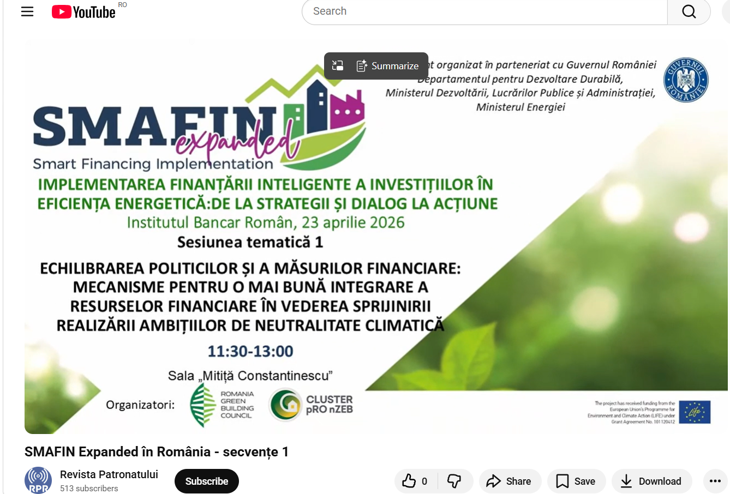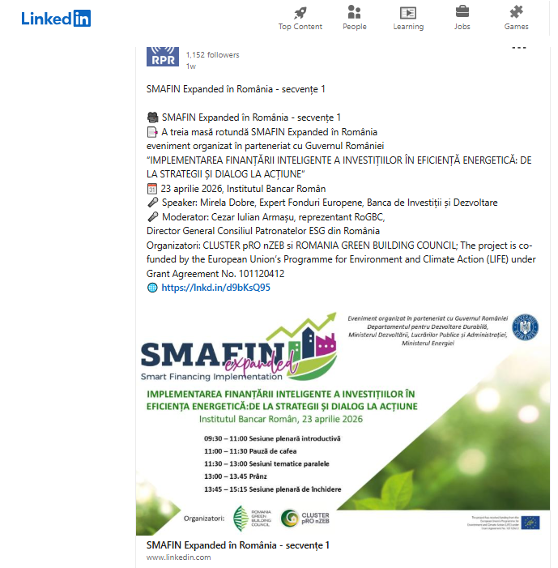

Figure 1. The Third SMAFIN EXPANDED RT published in the Romanian Employers’ Association Magazine and the Entrepreneur Club Magazine

The general theme of the event was “IMPLEMENTING SMART FINANCING FOR ENERGY EFFICIENCY INVESTMENTS: FROM STRATEGIES AND DIALOGUE TO ACTION”.
The topics of the parallel sessions, as discussed and agreed upon by the members of the working group, were:
- Balancing policies and financial measures: mechanisms for better integration of financial resources to support the achievement of climate neutrality ambitions;
- Monitoring the implementation of energy efficiency projects in buildings and overcoming challenges;
- Sustainable financing for energy efficiency in the tertiary sector and industry.
The RT began with an opening plenary session, followed by parallel thematic sessions to which participants were allocated according with the option they had selected upon registration. Following the conclusion of the three parallel sessions, the guests reconvened for the closing plenary session.
The plenary sessions were moderated by Ms. Miruna Mihailovici, journalist. Each parallel thematic session had both a moderator (who coordinated the session) and a rapporteur (who summarised the relevant points from the discussions).
The agenda for the final session included presentations of general interest and the rapporteurs’ summaries of the debates from the three parallel thematic sessions. General conclusions regarding the entire event were also drawn up, to be used as a basis for finalising the SMAFIN Expanded activities, primarily to identify potential public policy recommendations to support national energy efficiency targets. At the same time, these are collaboration pathways with the National Hub of the European Energy Efficiency Finance Coalition, coordinated by the Ministry of Energy, and for supporting its activities as part of the SMAFIN Expanded project’s sustainability strategy.
The detailed agenda for the event is attached to this report and was distributed to participants upon registration.
All topics focused on discussing, refining and validating policy recommendations to support the energy efficiency sector. As the event is primarily designed as a forum for debate, in addition to the relevant presentations, generous time slots were allocated in the agenda for discussions.

INTRODUCTORY PLENARY SESSION

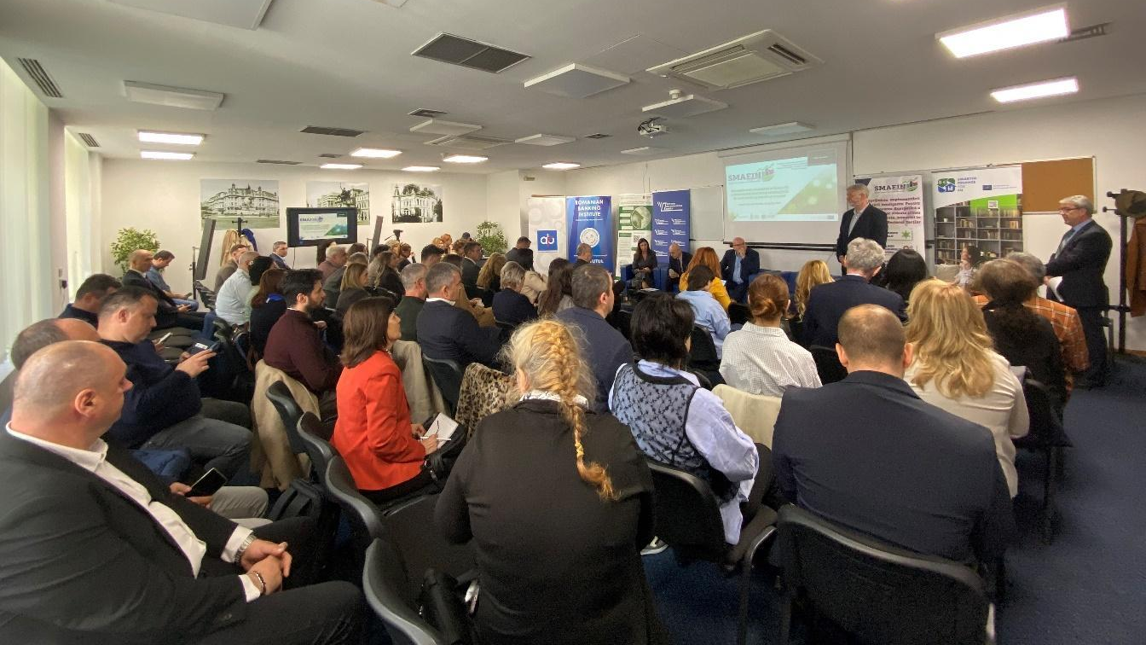
Figure 2: Photo impression from the Introductory Plenary Session

The event was opened by Mr. Horia Petran, representing the SMAFIN Expanded project team. The session moderator took over the coordination of the discussions, emphasising the importance of inter-institutional dialogue in identifying effective ways to mobilise capital to support national climate neutrality targets. During the introductory plenary session, various stakeholders presented their perspectives on energy efficiency and the financing of the energy transition:
The representative of the Ministry of Environment, Waters and Forests (MMAP) opened the series of presentations with a strategic observation: the fundamental challenge does not lie on the supply part — predominantly represented by the participants to the RT— but rather on creating the demand. In the absence of informed and committed demand from end users, ambitious theoretical concepts such as decarbonization or energy efficiency risk not to be reflected in the everyday behaviour of citizens and companies. The cross-cutting difficulty of communication — translating technical expertise into language that end users can understand — was identified as an ongoing challenge that requires additional tools for facilitating the dialogue with the final beneficiaries.
The representative of the Romanian Energy Efficiency Fund (FREE) emphasised that energy efficiency remains one of the national priorities. FREE, established 25 years ago by a Government Decision at the initiative of the World Bank (which provided an initial grant of US$8 million), has invested US$32 million over the course of its operations, supporting total investments of US$90 million, resulting in over 200,000 tonnes of emissions avoided annually and approximately 75,000 tonnes of oil equivalent saved per year. However, it was acknowledged that these figures remain insignificant compared with the actual needs for the sustainable transformation of the built environment and industrial processes.
It was noted that energy efficiency becomes a public priority particularly during periods of energy price crises, with intervention thus becoming a reactive measure. FREE is currently facing intense competition in a mature market, marking a paradigm shift from its initial pioneering position. The forthcoming European financial framework will phase out 100% grants, steering funding towards blended finance mechanisms based on co-financing and performance — loans, grants conditional on meeting targets, and technical assistance — direction reflected in initiatives such as the Multiregional Investment Platform managed by the EIB and the EBRD’s ‘Green Energy Finance Facility’.
The representative of DG Energy (EC) highlighted the significance of the moment in the context of the Commission’s recent communication on ensuring affordable and secure energy. The commitment to climate neutrality by 2050 and the central role of the Green Deal were reaffirmed, with emphasis placed on the need for closer integration between industrial and energy policies to support competitiveness, energy affordability and citizens’ purchasing power. Major initiatives currently being implemented were presented — strategies for heating and cooling, electrification, energy infrastructure, digitalisation and the Citizens’ Package — linked to the implementation of the revised directives on energy efficiency, renewable energy and the energy performance of buildings. At the same time, the importance of energy security and system resilience were emphasised, against the backdrop of pressures on critical resources and materials.
The representative of the Pro-nZEB Cluster pointed out that the diversity of programmes and funding sources for energy efficiency is excessively fragmented and requires better coordination. Although public funds are on the rise, they will not be sufficient to meet needs, and their strategic use is necessary to attract private capital and savings from the general public. Optimal solutions were identified in combining performance-based grants with financial instruments such as subsidised loans and state guarantees, so that the costs for beneficiaries become affordable and are offset by the savings generated. The importance of effective communication was also emphasised, to help beneficiaries perceive energy renovation as a worthwhile investment, as well as the need to collaborate with international financial institutions to develop integrated and sustainable solutions.
The RoGBC representative highlighted the value of round-table discussion formats, particularly in the context of political instability with significant economic implications. It was noted that the EU is increasingly promoting collaborative frameworks, such as the European Coalition for Energy Efficiency Financing, to ensure long-term continuity and coherence, thereby reducing the influence of political cycles. In contrast, at national level, there was a lack of engagement and a reluctance to collaborate with the private sector, necessitating a change in approach. The need for Romanian authorities to develop similar inclusive models was thus emphasised, as was the importance of more active participation by financial institutions, the private sector and professional organisations, to build effective and sustainable public policies.
The MMAP representative reiterated the idea of policy continuity, regardless of political factors, and offered a critical perspective on grants, which can lead to dependency and temporary market bottlenecks — an illustrative example being the situation where the announcement of plans for a new ‘Casa Verde’ programme leads to a halt in sales until its actual launch. Experience with the implementation of the National Recovery and Resilience Plan (PNRR) has highlighted a lack of resource planning for the operational phase of investments, leading to situations where completed investments are not actually utilised. It was noted that the key element lies in improving communication with the public and educating citizens to understand the mechanisms through which energy efficiency leads to cost reductions, so that they are willing to make an investment that will bring them both greater comfort and short-term financial benefits. It was also emphasised that reliance on public policy decisions is not sustainable, and that better alignment is needed between the logic of the public sector and that of the private sector. From the perspective of the communications specialist, it was highlighted that the public will never directly demand investment in energy efficiency but will consistently express a desire for energy bills to be close to zero.
The representative of the Romanian Association of Energy Auditors for Buildings shared this view, arguing that excessive reliance on grants does not yield long-term benefits. The existing disconnect between end-users, beneficiaries and policymakers was highlighted, emphasising the need to rebuild a collaborative relationship in which responsibilities are shared among all stakeholders. At the same time, shortcomings were highlighted in the implementation of certain financial products, such as programmes for energy-efficient housing, particularly due to a lack of monitoring and verification of how funds are used.
The FREE representative introduced the ETS2 mechanism into the debate, as it is designed to stimulate demand for investment in energy efficiency by imposing costs for emissions generated by buildings. It was noted that the application of this mechanism could lead to increased interest in investment in the buildings sector, based on the ‘polluter pays’ principle. From MMAP’s perspective, it was pointed out that a cautious approach was being taken to the implementation of ETS2, given the pressure created by tight deadlines and the preference for immediate benefits in contrast to the long-term investments specific to the energy transition.
The debate on the role of the state was opened by the FREE representative within the European Energy Efficiency Financing Coalition, who proposed a clearer definition of the state’s role in the field of energy efficiency, as currently it is perceived primarily as the administrator of state aid, grants and guarantees, to the detriment of its role as a regulator. The lack of standardised mechanisms for monitoring and verifying performance was highlighted, like those existing in other systems, where independent technical expertise is used to analyse data and resolve any disputes.
From the MMAP’s perspective, the perceptions of the state’s role are varied, highlighting gaps in governance and coordination between institutions — particularly between ministries — when it comes to establishing common and harmonised directions. It was suggested that the state should be viewed as a group of decision-makers, and the dialogue must be tailored to each level of intervention.
The representative of the pRO-nZEB Cluster emphasised the need for balance in the regulatory processes, avoiding both over-regulation and insufficient regulation. The state’s role was described as one of coordination and arbitration within a collaborative governance model, emphasizing the importance of continued dialogue with the market, the business community and civil society organisations. In addition, the MMAP representative emphasised the need for this dialogue to focus not only on the problems but also identify together two or three potential solutions for each situation, given the challenge of retaining experts for working in the public sector.
The complexity of the field of energy efficiency was highlighted, as it involves multiple institutions, funding mechanisms and categories of stakeholders, which calls for an integrated approach. At the same time, it was emphasised that, beyond regulation, it is essential to prepare the market through communication and education, with a view to raising beneficiaries’ awareness and engagement. They must be aware of the benefits of the investments and take responsibility for them, avoiding exclusive reliance on public support.
The RoGBC representative concluded that the state’s role should be assessed in the context of each sector’s specific characteristics. They highlighted that some sectors in Romania already have effective self-regulatory mechanisms, where stakeholders develop rules that serve users’ interests. The discussion underscored the need to balance regulation with flexible, market-led approaches, with the state acting primarily as an arbitrator.

PARALLEL THEMATIC SESSIONS

PARALLEL THEMATIC SESSION 1:
BALANCING POLICIES AND FINANCIAL MEASURES: MECHANISMS FOR BETTER INTEGRATION OF FINANCIAL RESOURCES TO SUPPORT THE ACHIEVEMENT OF CLIMATE NEUTRALITY AMBITIONS
Moderator: Cezar Armașu, ROGBC, Director-General of the Romanian ESG Employers’ Council, Director of the Romanian Employers’ Magazine.
Rapporteur: Ileana Botez, Director of Listing and Trading, Bucharest Stock Exchange

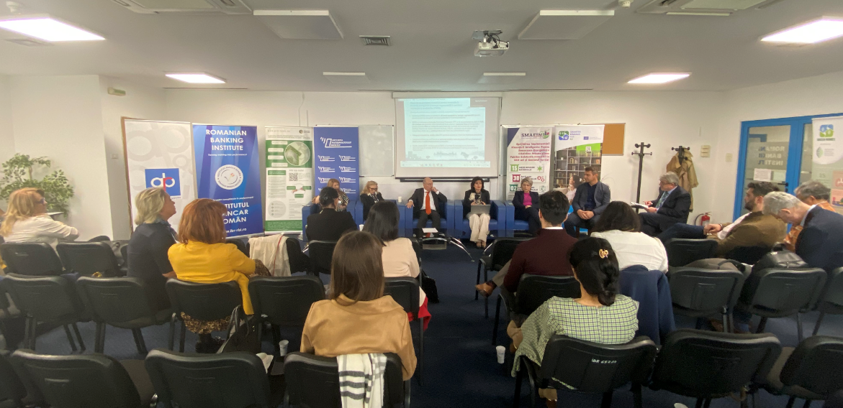
Figure 3: Image from Parallel Thematic Session 1

CONTEXT OF THE DEBATE
The moderator opened the session by introducing the panellists, who were representatives of the following institutions: MDLPA, the European Investment Bank – Romania Office, the European Bank for Reconstruction and Development – Romania, the Romanian Commercial Bank, the Romanian Investment and Development Bank, and the South Muntenia Regional Development Agency.

EUROPEAN INVESTMENT BANK (EIB)
To set the context for the debate, the EIB representative presented key statistical data: 42% of Romania’s final energy consumption is attributed to the buildings sector, of which 34% is accounted for by residential buildings and 8% by non-residential buildings — figures that highlight the significant potential for energy efficiency improvements. The benefits of this process go beyond simply reducing consumption and the carbon footprint, extending to job creation, extending the lifespan of the housing stock and reducing costs for the end consumer.
The Multiregional Platform, currently in the preparatory stage, was presented, with estimated funding allocations of €240 million for residential buildings and €45 million for public buildings. Implementation through the Regional Development Agencies is driven by the need to aggregate demand, as the individual values of the projects (ranging from €1.5 to €5 million for public buildings and from €20,000 to €150,000 for residential buildings), require the creation of coherent portfolios managed by financial intermediaries. The selection phase for intermediaries has been completed; the timetable provides for the announcement of the successful bidders in the second quarter, the signing of contracts in the third quarter, the start of implementation by the end of 2026 and its completion by the end of 2029. To offset the operational complexity, the financial terms on offer are particularly favourable: zero-interest loans and a capital rebate of up to 50%, as well as a performance grant.
The EIB’s track record in Romania in the field of energy efficiency amounts to nearly €700 million in loans, of which approximately €660 million has already been disbursed and injected into the economy. The programme, launched in 2009, has focused primarily on the municipal sector, with Bucharest’s districts among the main beneficiaries — four of which have repeatedly accessed such funding, demonstrating the effectiveness of the instrument and a clear learning curve. The competitive advantages of EIB loans include favourable interest rates, grace periods tailored to the duration of implementation, and extended repayment terms — with a repayment period of 15 or 16 years estimated for the multi-regional platform.
In the subsequent discussion, the audience sought clarification on the costs borne by the final beneficiaries; it was confirmed that these vary by sector, while the presence of such costs makes it more difficult to attract beneficiaries and depends directly on how local authorities structure the financial arrangement.
The complexity of EPC Plus contracts for local authorities was also highlighted, particularly for public buildings. The high investment costs mean that a 15-year repayment period is insufficient in the absence of a significant contribution from the local authority, thereby affecting the viability of ESCO contracts. Added to this is the limited administrative capacity of many local authorities to manage these contracts, illustrated by the example where, with a 50% reduction in an annual bill of €1 million, the local authority has not clarified how the savings will be allocated to pay for ESCO services. The EIB representative responded by highlighting two points: EIB financing reduces project costs and is, as a rule, combined with non-repayable European funds; and, regarding implementation capacity, the EIB offers free technical assistance through the ELENA programme and InvestEU, supporting project preparation and long-term financial modelling.

EUROPEAN BANK FOR RECONSTRUCTION AND DEVELOPMENT (EBRD)
The EBRD’s representative in Romania noted that the financing of buildings was predominantly provided through European funds in the form of full grants, a widespread practice in the residential sector. The reduction in the grant level from 100% to 80% led to a sharp decline in the number of projects, a phenomenon reflecting beneficiaries’ accustomed reliance on the absence of any own contribution — a situation regarded as unnatural, except for those sections of the population who cannot afford to contribute financially. Looking ahead, European funds will operate differently from the current model, with the focus shifting towards financial instruments and private-sector participation in financing structures.
Unlike the EIB, which is the European Union’s bank, the EBRD is an international financial institution with a broad geographical scope, ranging from Central Europe to Central Asia, the Mediterranean region and Africa. As a development bank, the EBRD combines financing with technical assistance — aimed both at preparing and structuring projects to ensure their bankability and at supporting the sectors it finances — and with policy dialogue, through engagement with central and local authorities.
The EBRD’s financing instruments in the building sector are structured around five areas: (1) direct financing to local authorities, utility companies and private ESCOs; (2) financing through partner banks, via loans, green bonds and risk-sharing facilities with local banks such as Banca Transilvania and Raiffeisen Bank; (3) an implementation partnership under the European Union’s InvestEU programme, through which the EBRD provides a guarantee of €450 million for green investments; (4) the Green Cities Programme, a €5 billion framework programme dedicated to the municipal sector; and (5) the Green Economy Financing Facilities.
During the current programming period, the EBRD is collaborating with the Ministry of European Funds through a guarantee facility worth approximately €500 million, designed to finance residential buildings via three selected partner banks. The programme, implemented through InvestEU, was recently launched and is now open for applications.
The institution’s experience with financing facilities for green projects implemented during the 2007–2013 and 2013–2020 programming periods was presented. Although European funds with grants of almost 100% were available during that period, they were initially underutilised. In contrast, the EBRD facility, which offered only a 10% grant from European funds, proved highly successful, a success attributed mainly to the technical assistance provided both to partner banks in project appraisal and to beneficiaries in project structuring. An additional incentive was the 10% bonus granted to beneficiaries who met their energy performance targets. A complementary scheme, targeting SMEs and private beneficiaries for buildings with a potential for reducing energy consumption by at least 20%, enabled the purchase of technologies from a pre-selected list, a mechanism that proved effective.
As regards the energy performance contracts, EBRD had provided support over a period of approximately 10 years to open the market in this sector. The process proved difficult, being hampered by an inadequate legislative framework — including the absence of clear rules on the accounting entry of energy savings — an issue that led to protracted negotiations with the authorities. Although there were concrete initiatives in three cities, these could not be finalised, whilst the model is widely used in other European Union member states; ANRE has recently resumed discussions on this issue. It was emphasised that the development of energy efficiency projects depends on the existence of a solid and consistent pipeline in the market, as one-off projects do not provide sustainability for ESCO companies.
Under the Green Cities Programme (a €5 billion framework programme), the EBRD is funding buildings in Brașov, Craiova (including the Town Hall, considered to be of outstanding architectural value) and a mix of buildings in Iași, including the transport depot. In conclusion, a key lesson was highlighted: in the context of co-financing with European funds, implementation in Romania is highly complex; for this reason, the hope was expressed that government authorities would ensure the necessary flexibility and consult with international financing institutions when defining funding guidelines and models. Lithuania was cited as a model, where the state-owned company VIPA provides substantial funding for the refurbishment of buildings, taking on some of the responsibilities of the government and local authorities.
Looking ahead, the next European programming period will make considerable funds available for ‘affordable housing’ — a distinct concept from social housing — targeting commercial models through which funding is made accessible to specific sections of the population: students, young people or professionals whom local authorities wish to attract. The implementation of such programmes will require public-private partnerships, an essential condition for the effective utilisation of the available funds.

ROMANIAN COMMERCIAL BANK (BCR)
The BCR representative emphasised the importance of focusing on the end-user’s needs, identifying four trends relevant to Romania: (1) the existence of a very large stock of energy-inefficient buildings, creating a particularly high demand for renovation; (2) the overlap of several crises, accompanied by a trend towards rising energy costs; (3) the acute need for digitalisation and the integration of artificial intelligence, which will lead to even higher energy consumption; and (4) the evolution of the regulatory framework as an essential factor in constructing any medium- and long-term financial model.
The impact of ETS2 on the costs borne by individuals was highlighted, particularly regarding heating, as end users are not currently sufficiently aware of the scale of these changes. Given that the cost of living is set to rise, the renovation and energy optimisation of buildings is a priority that should be on every citizen’s agenda.
BCR’s sustainability strategy, which has been pursued at group level for several years, has as its central objective supporting the green transition, both through dedicated financial products and robust educational programmes. The institution has invested heavily in financial education over the last 10 years, and this is now complemented by education on the green transition, sustainability and energy efficiency.
As regards the portfolio, over 70% of the commercial buildings financed have certified energy efficiency, whilst in the retail segment, green mortgages account for approximately 30% of the portfolio. Decarbonisation is the second key component of the strategy, with clear targets for reducing emissions by 2050 and significant interim targets set for 2030. A further measure adopted is the exclusion to finance buildings classified as energy efficiency class D. The major challenge remains the approximately 70% of buildings that do not fall into energy efficiency classes A or B; partnerships and blended finance mechanisms are regarded as essential tools, particularly for individuals who need to be offered financing at an attractive cost, with extended repayment terms and a flexible collateral structure.
It was acknowledged that the renovation products offered to date have predominantly taken the form of short-term consumer loans, which are difficult to sustain in terms of repayment capacity. The main obstacle in customer relations remains a lack of awareness, illustrated by attitudes such as the unjustified postponement of renovation work or reluctance to take out a loan in the absence of an immediate need. A targeted nationwide awareness campaign, supported by low-cost financing packages, is therefore a priority.
In the corporate sector, BCR finances the replacement of equipment as part of industrial energy efficiency projects, with the main difficulty being the verification and quantification of the energy efficiency gains achieved. The additional documentation required in the green lending process — energy certificates, audit reports — represents a cost and a source of delay, and the development of a digital workflow capable of reducing processing time has been identified as a strategic priority. The relevance of the data was illustrated by the institution’s experience with the reporting process under the CSRD Directive, now in its second year of implementation. In summary, BCR reaffirmed that energy renovation remains a major strategic priority, with funding for industrial equipment replacement programmes being conditional upon demonstrating a minimum energy efficiency improvement of 30%.

MINISTRY OF DEVELOPMENT, PUBLIC WORKS AND ADMINISTRATION (MDLPA)
The MDLPA representative emphasised the main issue remains funding, in the context of implementing the obligations arising from Directive 1275/2024 on the energy performance of buildings. Romania is currently in both the transposition and implementation phases, including through the development of the National Digital Register of Buildings. The National Renovation Plan (first preliminary draft), drawn up in collaboration with the World Bank, was submitted to the European Commission on 30 December and is under revaluation by the EC, while at the end of the process will be due to be adopted by a Government Decision.
Romania’s main obligation is to carry out energy-efficiency refurbishment on 16% of its worst-performing buildings by 2030. A comprehensive analysis of the national building stock has highlighted that the funding requirement is overwhelming: around €30 billion by 2030 and over €100 billion by 2050, the latter sum covering only the energy performance component, excluding seismic retrofitting, fire safety or accessibility for people with disabilities. It was strongly emphasised that the amount required by 2030 cannot possibly be met solely through public funds, and that private sector involvement is essential.
In this context, reference was made to the minimum energy performance standards (MEPS) proposed by the directive, the transposition of which is experiencing delays. These standards are not merely methodological values, but mandatory thresholds similar to those implemented in other Member States. In France, a report by the Court of Auditors assessed the implementation of these standards, concluding that buildings not renovated within a certain timeframe can no longer be inhabited — restrictive measures, but ones that act as an effective incentive.
The state-guaranteed loan scheme for the renovation of individual buildings, which had been available under a legislative framework in place for 15 years, was repealed this year as citizens were not making use of the scheme, the main reason being the absence of any legal obligation to renovate. Achieving the mandatory minimum targets is conditional on the mobilisation of all available sources of funding. Looking ahead, various types of financial products will need to be developed and ways identified to leverage the allocated European funds.
In addition to the financial aspects, the question was raised regarding the operational capacity to meet these targets by 2030 — namely, the availability of skilled workforce in design and construction, as well as building materials. Several Member States, including Romania in its cover letter accompanying the preliminary version of the national renovation plan, have pointed out to the European Commission that the targets set are particularly ambitious. It was pointed out that the simultaneous launch of a wave of renovations across Europe could place significant pressure on supply chains, a phenomenon already being felt in the Romanian construction market due to the situation caused by the war.
The importance of partnership with the banking sector in the national energy renovation effort was emphasised; as part of the preliminary consultation process on the National Renovation Plan, meetings were organised, including with the Romanian Banking Association. The objective of energy renovation goes beyond the strict framework of compliance with European requirements, aiming equally to improve quality of life, reduce energy poverty and increase citizens’ ability to meet their heating costs.
An important clarification has been made regarding the understanding of the concept of energy-efficient renovation, which in the public perception is often reduced to the application of a layer of thermal insulation. Energy renovation encompasses a much broader range of measures — including photovoltaic panels, heat pumps and building management systems (BMS) — all of which are eligible under the funding programmes.
A major difficulty highlighted is the lack of a clear picture of the national renovation rate, caused by the fragmentation of data across multiple institutions — renovations carried out through national programmes, European programmes, loans taken out by local councils from the EIB or the EBRD which are not reported to the Government, or through private initiatives — without these being centrally collated. The National Digital Buildings Register will address this challenge, with each building to have data associated with it — in a centralised and transparent system — regarding its energy performance certificate, seismic risk, planning status, tax status and other relevant information.
It was noted that clear political decisions will be required to develop the necessary financial instruments. The provision of 100% non-repayable funding is to be restricted to strictly defined segments of the population, whilst diversified financing instruments will be developed for the remaining beneficiaries, in partnership with the financial sector.

Further comments on ETS2 and a proactive approach to financing
The EIB representative pointed out that the ETS2 scheme aims to create a source of revenue for Member States and is due to come into force in 2028. The EIB has a pre-financing instrument through which it can advance funds to Member States based on the estimated volume, with the aim of accelerating the start of the renovation process. This mechanism functions as a bridge loan; the sums are not included in the calculation of the budget deficit but are treated as pre-financing.
The EBRD representative identified a recurring structural problem in the way Romania approaches European funds: the tendency to passively wait for all funding conditions to be clarified before taking any action. A typical cycle was described in which the seven-year programming period is overwhelmingly consumed by successive stages of waiting and preparation — clarification of the European Union’s priorities, drafting of European guidelines, drafting of national guidelines, preparation of pre-feasibility and feasibility studies, and the conduct of procurement procedures — with the result that the first five years are used up without any actual work having begun, whilst the final two years are devoted to reallocating funds between funding axes to avoid losing the funds.
In this context, a proactive approach has been proposed: given that the need for rehabilitation is clear, the European commitment has been undertaken and future funds are anticipated, Romania could begin funding and preparing projects four to five years in advance, using any available source, with the expenditure incurred to be submitted for reimbursement once European funds are accessed, and the difference to be covered through co-financing. This model is being successfully applied by countries such as Poland and Spain.
The MDLPA representative confirmed that there is already a considerable number of energy renovation projects ready to go, but emphasised the need to transition towards moderate and in-depth renovation, as opposed to the model applied until recently, in which works carried out through operational programmes and from the state budget were often substandard.

The capital market as a complementary source of funding
The representative of the Bucharest Stock Exchange raised a complementary perspective, emphasising that financial resources exist both within Romania and abroad, provided they are identified and utilised wisely. Attention was drawn to the underutilised potential of the capital market, through which local authorities, banks and private companies can issue green bonds, attracting both domestic capital — pension funds, investment funds and household savings — and international institutional investors.
A telling figure was cited in support of this argument: individuals currently hold €77 billion in bank accounts, of which approximately 65% is in demand deposits and 35% in fixed-term deposits — resources that could be channelled into green investment instruments. Some banks, such as BCR and UniCredit Bank, have already issued green bonds, but the private corporate sector remains virtually absent from this segment, the only notable exception being an issue by the private company Autonom to finance a fleet of electric vehicles.
A critical observation was made regarding the absence of an integrated macroeconomic approach to the financing of energy-efficiency refurbishment, characterised by an excessive reliance on European funds and a lack of coordination between the various available sources of capital. The EIB representative added that both the EIB and the EBRD can participate as investors in green bond issues, citing ELECTRICA as a concrete example.

THE INVESTMENT AND DEVELOPMENT BANK (BID)
The representative of the BID — a financial institution wholly owned by the state through the Ministry of Finance —, stated that it is already active in the market through its first products: the individual guarantee and the capped guarantee. The institution aims to support SMEs, underpin infrastructure, meet long-term strategic investment needs and facilitate access to European funds. The pillar-based assessment audit has been completed with a view to obtaining the status of an implementing partner of the European Commission, with access to funds under indirect management, such as InvestEU.
Energy efficiency has been identified as one of the institution’s objectives within the infrastructure component. Two major financial instruments have been presented:
Firstly, the Equity Fund Financing Agreement, signed with three regional programmes (Bucharest-Ilfov, North-East and South-East), aimed at SMEs wishing to make initial investments in tangible and intangible assets, including energy efficiency and green investments. The instrument combines a low-interest loan with a grant component, in the form of a 40% capital rebate applied upon completion of the investment, subject to the fulfilment of the agreed conditions.
Secondly, the Just Transition Instrument, signed at the end of March 2026, aimed at the six counties: Dolj, Gorj, Hunedoara, Galați, Prahova and Mureș. The instrument incorporates the provisions of the STEP Regulation, recognising the role of large enterprises and the need to bridge the gaps in the fields of critical materials and advanced technologies. Implementation is carried out in partnership with the Managing Authorities and the JASPERS team.
The BID’s partner financial institutions, as of March 2026, are: BRD, BCR, Eximbank — Banca Românească, Banca Transilvania, ING, Libra Internet Bank, UniCredit Bank, CEC Bank, Raiffeisen Bank, Intesa Sanpaolo Bank and Patria Bank.

SOUTH MUNTENIA REGIONAL DEVELOPMENT AGENCY (RDA)
The representative of the South Muntenia RDA presented the structure of the available funding, organised into three categories of interventions: calls for phased projects (continuations of previously initiated investments); calls for new ‘ ’ projects (the largest volume of investment); and a call dedicated exclusively to public buildings, developed with the support of the ELENA initiative, through which the technical documentation was prepared. The demand expressed under this call exceeded the available allocation of approximately €100 million, with the projects submitted totalling around €150 million; the difference is explained by the significant rise in construction prices compared with the initial estimates made in 2021–2022.
The South Muntenia Regional Development Agency (ADR Sud Muntenia) is part of the Multiregional Platform with an allocation of €141.17 million — the largest within the platform — earmarked exclusively for detached houses and residential buildings. The scheme combines a loan with a grant component proportional to the level of energy efficiency achieved: for efficiency levels between 30% and 40%, the capital reduction is 30%; for 40%–50%, the reduction rises to 40%; and for efficiency exceeding 50%, the capital reduction reaches 50% of the loan amount.

QUESTIONS AND DISCUSSIONS – institutional coordination
A member of the audience raised the issue of whether there is a coordination mechanism between the institutions present, designed to prevent overlaps and competition between the available funding schemes.
The MDLPA representative highlighted that coordination structures already exist — the Energy Performance Committee and the Interministerial Committee on Climate Change — and that the real problem is the absence of concrete mechanisms for collaboration between ministries. The BCR representative emphasised that the €30 billion required by 2030 entails extensive coordination and planning, focusing not only on funding sources but also on implementation capacity — builders, designers and materials.
The EIB representative noted that information and training schemes are being run through MIPE, suggesting that more frequent sector-specific meetings be organised. The funding requirement is even more complex, given the large number of buildings requiring both energy efficiency improvements and seismic retrofitting, in addition to historic monuments. The MDLPA representative confirmed that the figure presented is an estimate which could be even higher. The reality of poor coordination was illustrated by the example of funding for charging stations for blocks of flats, provided simultaneously through the PNRR and the Environment Fund, in the absence of any prior coordination.
The EBRD representative concluded that, although there are numerous institutions with responsibilities in the field of energy efficiency, none assumes full responsibility, expressing the view that a lead ministry should be designated, including for achieving the climate neutrality targets by 2030. A summary conclusion was drawn: the expertise exists in the market, the financial resources are available, but there is a lack of functional funding mechanisms tailored to actual needs.
It was pointed out that the Ministry of European Investments and Projects (MIPE) does not, and should not, draw up sectoral policies, yet it sometimes claims this right, rejecting proposals from line ministries. Responsibility for energy policy lies with the Ministry of Energy, whilst responsibility for the energy performance of buildings lies with the MDLPA — this ministry should be the main point of contact for the financial institutions involved.
The RoGBC representative raised once again the issue of coordination, emphasising that the solution cannot lie solely in escalating decisions to the political level. The recently launched National Hub of the European Coalition for Energy Eficiency Financing was mentioned as a platform aimed at achieving this type of multi-stakeholder coordination. The MDLPA representative announced the intention to develop a dedicated Affordable Housing Hub with a building renovation component. RoGBC emphasised that the involvement of all relevant stakeholders — including the private sector, banks and civil society — is essential for the long-term effectiveness of this initiative.

A second question concerned the timeline for the National Digital Buildings Register to become operational. The MDLPA representative stated that the Register is due to become operational from April, with a section dedicated to projects renovated under the PNRR available online from July. From 2027, Romania will be required to transfer data from the National Register to the European Buildings Observatory.

PARALLEL THEMATIC SESSION 2:
MONITORING THE IMPLEMENTATION OF ENERGY EFFICIENCY PROJECTS IN BUILDINGS AND OVERCOMING CHALLENGES
Moderator: Gabriela Sterian, Project Director, TEC Cluster, Public Policy Expert, pRO-NZEb Cluster
Rapporteur: Cătălin Lungu, Bucharest Technical University of Civil Engineering / President of OAER

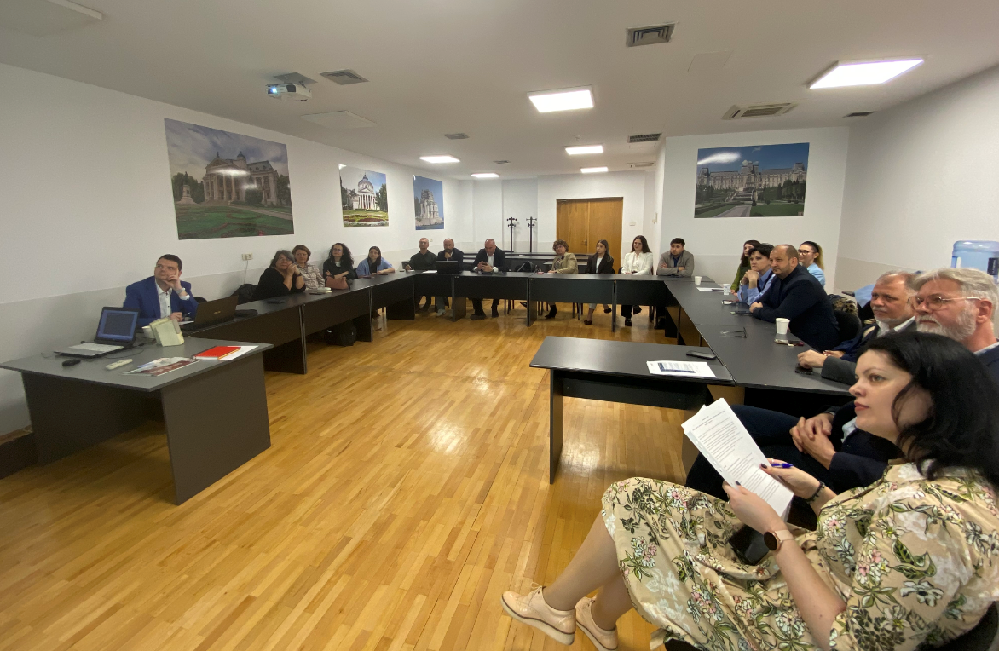
Figure 4: Image from Parallel Thematic Session 2

FRAMEWORK OF THE DEBATE
At the start of the session, the moderator raised some key questions to structure the debate: how projects are implemented and how their effectiveness is measured?; what lessons can be drawn from the experience gained; and (given the high volume of funding available)?; is all the necessary input data in place to generate concrete and measurable results, addressing actual problems that have been identified, not just to make use of the available tools?
The following organisations were represented in the debates: the pRO-nZEB Cluster; UTCB/OAER; MDLPA; the Association for Integrated Territorial Development of the Jiu Valley; GUEE Ilfov; the EfdeN Association; RoGBC; the Resource and Expertise Centre for Climate Change, Energy Efficiency and Heat Pumps (the successor organisation to the Energy Efficiency Agency); Raiffeisen Bank; Energy Policy Group; the Romanian Buildings Association; and the Department for Sustainable Development.

MINISTRY OF DEVELOPMENT, PUBLIC WORKS AND ADMINISTRATION (MDLPA)
The MDLPA representative presented the status of the National Digital Building Register (NDBR), a large-scale project for which there has long been a recognised need. The system will not only centralise data on energy performance but will also aggregate all information associated with a building, thereby constituting a comprehensive national database. The lack of a centralised database has been a major problem both in drawing up the Long-Term Renovation e Strategy and the National Seismic Risk Reduction Strategy, as well as in drawing up the National Building Renovation Plan.
The project, included in the National Recovery and Resilience Plan (NRRP), was awarded at the end of last year, and its actual implementation has begun. The register must become operational by the summer of 2026 — a firm commitment made to the European Commission. The main challenge at present is to populate a pilot area with data on buildings renovated and reinforced under the NRRP.
The system is structured around three components: public (accessible to any user); protected (accessible to authenticated users); and restricted (accessible exclusively to users with special rights).
The fundamental principles of the NDBR are: the assignment of a unique code — the Spatial Identification Number (NIS) — to every building at national level; and the requirement that all documents issued in relation to a building must bear this unique code and be integrated into the system. The documents covered include town planning certificates, building/renovation permits, building completion certificates, energy audit reports, energy performance certificates and renovation passports. The system will be capable of generating standardised data sets at building level, tracking the 30 indicators set out in the European Energy Performance Directive.
Regarding the technical architecture, user authentication is carried out via national digital infrastructures — ROeID and, shortly, the electronic identity card — without the system managing its own accounts. Access rights are granted automatically based on the user’s status in relation to the building, through interconnection with the Ministry of Development’s public registers for regulated personnel and through interconnection with the National Agency for Cadastre and Land Registration (ANCPI) for owners. The authorisation process for experts is fully digitised, with access rights granted automatically once their professional licence is valid.
A technical difficulty has been reported concerning public institutions, caused by the absence of a national system linking the status of authorising officer to the identification details of the responsible individual — information held by the Treasury but not integrated into a digitalised system. The system is designed to communicate with public institutions via ROePASS and with citizens via ROeID.
The register essentially functions as a document reception system. In the case of the energy performance certificate, the metadata and indicators must be submitted in a structured XML format, not exclusively in PDF format, to enable automatic data processing. The platform will provide a dedicated tool for generating the renovation passport, the first of its kind available in Romania. The building owner has access to the building’s file and can manage it directly, whilst also being able to grant third parties limited-time access via a QR code.
All events in the building’s life cycle are recorded in a logbook secured by blockchain technology, which prevents retroactive alteration of the data. The building profile will include the following details: identification, ownership, planning status, use and function, structure and materials, energy performance, installations and smart readiness.

Discussions on the operationalisation of the Register
Clarification was sought on how the Register can be transformed from a simple database into a genuine tool for informing decision-making. It was stated that the main mechanism is the legislative framework, through the establishment of mandatory checkpoints, without which the next step in an administrative process cannot be taken. Consideration is also being given to introducing a requirement that official documents relating to a building must be submitted to the system within a predefined timeframe.
Regarding the mapping of NIS codes to existing identifiers (administrative address, cadastral number), it was explained that the system would be initialised by importing data sets from ANCPI and assigning NIS codes to all existing records. However, the ANCPI database does not fully cover the actual building stock — there are buildings for which energy performance certificates have been issued but which are not registered with ANCPI. The fragmentation of building registers across institutions — the Ministry of Finance, the Directorate for Assets and Database Management and ANCPI, each operating with their own reference systems — represents one of the main challenges in the data consolidation process.
The system is designed around four levels of disaggregation: the individual unit (flat, parking space); the energy unit (floor or part of a floor); sections (structurally relevant); and building parts (defined in urban planning terms, in accordance with the European INSPIRE standard). Each level has its own NIS.
Regarding experts’ access to data, it was explained that authorized professionals with the right to practise freely are granted automatic access to the datasets corresponding to their area of authorisation, without the need for individual approval from the owner. The European Directive explicitly stipulates that access for experts must be granted by the data owner, which raises the issue of harmonising the technical approach with legislative requirements — the level of digital maturity of most data owners justifying the retention of automatic access as the primary solution.
Owners are not obliged to enter data into the system — this responsibility lies exclusively with authorised experts. If a building does not have an NIS, the expert may initiate its registration in the repository, obtaining a provisional NIS with a low level of confidence. Regarding the legal status of documents, it is envisaged that the energy performance certificate registered in the system will acquire the status of an original document.
A proposal was made from the floor to create a simplified public portal where any potential buyer could check basic documentation — planning permissions, energy class, and the building’s history — in response to real needs of the property market; the response confirmed that such a portal is planned.

ASSOCIATION FOR INTEGRATED TERRITORIAL DEVELOPMENT OF THE JIU VALLEY (ADTI VALEA JIULUI)
The representative of ADTI Valea Jiului outlined the specific context of the region, which is in transition from an economic model based on the coal extraction towards promotion of its industrial heritage, within the framework of the ITI (Integrated Territorial Investments) mechanism. The association acts as a consultative hub for both local stakeholders and the managing authorities and the Ministry of European Funds.
Among its strategic objectives is the transformation of the Jiu Valley into an area with a sustainable energy profile, through the transition from a carbon-intensive model to one based on renewable energy and energy efficiency. Two flagship projects have been identified, aimed at establishing energy communities with production and storage capacity. It was emphasised that the ‘Energy Efficiency First’ principle is essential — energy production cannot be separated from improving energy efficiency.
The region benefits from a dedicated allocation of over €30 million, the absorption of which represents a real challenge, given the limited administrative capacity of the six municipalities and towns in the area. Technical assistance has been requested from the EIB, the EBRD and the BID to prepare project portfolios. Funding has focused primarily on residential buildings, with access conditional on the integration of homeowners’ associations into the energy community — both as producers and as consumers.
A specific problem encountered on the ground was highlighted: the data held by the Land Registry and Property Advertising Office did not correspond to reality, with the registered areas being smaller than those measured. The proposed funding model combines a grant-based instrument with a component requiring an owner’s own contribution, accompanied by a support mechanism for vulnerable individuals — a loan repayable over 5 or 10 years, depending on income.
The issue of the link between the reported performance indicators and the data recorded in the Register was raised — specifically, how to identify the source of funding for a renovation, the value of the investment and the results achieved. It was acknowledged that the source of funding is not currently recorded at the level of the investment file, but will be specified in the renovation passport. The link between the amounts spent and the concrete results — kilowatt-hours saved, reduced emissions — is not currently established automatically.

ILFOV ONE-STOP SHOP FOR ENERGY EFFICIENCY (GUEE)
The representative of GUEE Ilfov presented the experience of implementing the voucher scheme for photovoltaic panels aimed at vulnerable groups, carried out under the RePower component of the PNRR. Of the approximately 80,000 vouchers issued, it is estimated that around 60,000 will be implemented. The one-stop shops were responsible for verifying documentation and issuing eligibility notices, without being involved in the actual funding process. The process of verifying documentation received in PDF format was carried out manually, requiring a significant amount of work — digitisation and the use of artificial intelligence would have significantly reduced the administrative burden.
It was noted that the one-stop shops were set up on the initiative of MIPE, without dedicated funding for equipment and staff, and operated using the existing resources of the county councils. MIPE failed to ensure effective coordination, with staff constantly seeking clarification on their responsibilities, including as regards the monitoring of works.
The issue of the actual quality of the works carried out was raised, with emphasis placed on the fact that monitoring implementation is not merely a matter of recording data but must focus on actual results — actual energy consumption compared with that estimated in the energy performance certificates. It was confirmed that this aspect had not been systematically addressed, with institutions limiting themselves to reporting the number of funded projects and the amounts spent.
A distinction was made between two types of monitoring: documentary monitoring — which the platform will provide — and monitoring of the actual results of implementation, namely comparing actual energy consumption before and after renovation. Monitoring of actual consumption was envisaged through interconnection with the Ministry of Energy’s system, with each NIS to be linked to the corresponding metering point.
The importance of actual monitoring was illustrated by the results of a study carried out on 75 blocks of flats in Sector 6, which highlighted an average difference of 40% between actual post-renovation consumption and the data in the energy performance certificates, after adjusting for external and internal conditions. At European level, in some cases the reduction in energy consumption in renovated blocks was as low as 10%.

EFdeN ASSOCIATION
The EfdeN representative presented the energy efficiency simulator developed by the organisation, drawing on the experience gained during the Solar Decathlon competitions. A key conclusion identified as long as 13 years ago is that, over a 30–50-year life cycle, the initial cost of a building accounts for only 20–30% of the total cost, with the remainder comprising capital and operational costs (CAPEX/OPEX).
The mission undertaken was to translate technical information into practical, accessible data for the end user — whether an owner, a homeowners’ association or a local council. The data relevant to beneficiaries is financial in nature: the total cost, the payback period for the investment and the savings generated. Interconnection with the NDBR will significantly simplify the data collection process, allowing users to access information relating to their building’s Energy Performance Certificate (EPC) directly.

ROMANIA GREEN BUILDING COUNCIL (ROGBC)
The information included in the presentation on the relevance of the EU Taxonomy to the buildings sector is included in the minutes:
The European context was outlined using three key figures: buildings account for approximately 40%of the European Union’s final energy consumption and approximately 36% of energy-related CO₂ emissions, with the target for a climate-neutral building stock set for 2050.
The EU Taxonomy is a technology-neutral classification system for environmentally sustainable economic activities, which creates transparency through mandatory reporting for major players. It is not a mandatory list of investments, does not constitute a sustainability rating for a company, and does not impose minimum performance requirements.
The European legislative framework for sustainable finance is structured around three interconnected pillars: the EU Taxonomy — Regulation (EU) 2020/852 — which classifies climate-aligned economic activities, including for buildings under activities 7.1 (new construction), 7.2 (renovation) and 7.7 (acquisition and ownership); the CSRD — (EU) 2022/2464 — on sustainability reporting (ESRS), to be phased in for approximately 50,000 companies in the EU between 2024 and 2028; and the SFDR — (EU) 2019/2088 — on the transparency of financial products.
The six environmental objectives of the EU Taxonomy are: climate change mitigation, climate change adaptation, sustainable use of water and marine resources, transition to a circular economy, pollution prevention and control, and the protection and restoration of biodiversity. The four cumulative conditions for ‘taxonomy alignment’ are: a substantial contribution to at least one of the six objectives; compliance with the DNSH (Do No Significant Harm) principle in relation to the other five objectives; minimum social and governance safeguards (OECD, UN); and technical selection criteria in accordance with the applicable delegated acts.
In figures, by 2024, taxonomy-aligned capital expenditure totalled €273 billion (€742 billion cumulatively over the period 2022–2024), representing 22.7% of eligible capital, whilst banks’ Green Asset Ratio stands at just 2.8%. In the construction sector, although 40% of capital expenditure is eligible, only 22% is aligned with the taxonomy, with just 3% of capital aligned at European level coming from construction — a gap attributed not to a lack of potential, but to the sector’s limited capacity to demonstrate compliance.
The technical selection criteria stipulate: for the construction of new buildings (activity 7.1) — primary energy consumption at least 10% below the national nZEB threshold, an airtightness test for buildings over 5,000 m² and a calculation of the global warming potential over the life cycle; for the renovation of existing buildings (Activity 7.2) — a reduction in primary energy consumption of at least 30% or the completion of a major renovation as defined by national legislation; for the acquisition and ownership of buildings (Activity 7.7) — compliance with energy class A for buildings authorised prior to 31 December 2020 or ranking within the top 15%of the national building stock.
A common interpretative pitfall was illustrated by a practical example: an office building with planning permission granted in 2019 and due for completion in 2024 cannot be reported under Activity 7.1, as the construction did not take place under the Taxonomy regime. The correct classification is Activity 7.7 — procurement, pre-2021 regime — with the relevant date being the date of the application for the building permit.
The current challenges in reporting, identified following the European Commission’s update of 17 March 2026, relate to three main issues: data fragmentation; the quality of energy performance certificates, with significant variations between experts and a discrepancy from actual consumption; and the insufficient integration of requirements concerning waste and climate risks. At the same time, the European Commission has begun reviewing the technical selection criteria, with adoption planned for the summer of 2026 and possible entry into force in 2027.
There are three key tools for credible reporting, which must operate in an integrated manner: the National Digital Building Register — a single source of data on the performance of the building stock; The Energy Performance Certificate — a fundamental criterion for taxonomy and green crediting; and the Building Renovation Passport — a tool for phased planning of deep renovation. In practice, the RoGBC solution consists of independent ESG verification via the BluAuditor platform, with a complete separation between consultancy and verification activities. RoGBC offers two certification schemes: Green Homes and the Taxonomy Alignment Certificate.

PARALLEL THEMATIC SESSION 3:
SUSTAINABLE FINANCING FOR ENERGY EFFICIENCY IN THE TERTIARY SECTOR AND INDUSTRY
Moderator: Adrian Ghiță, Executive Director, Romanian Energy Efficiency Fund (FREE)
Rapporteur: Manuela Drăghicescu, Executive Director, New Energy Sources Employers’ Association (SUNE)
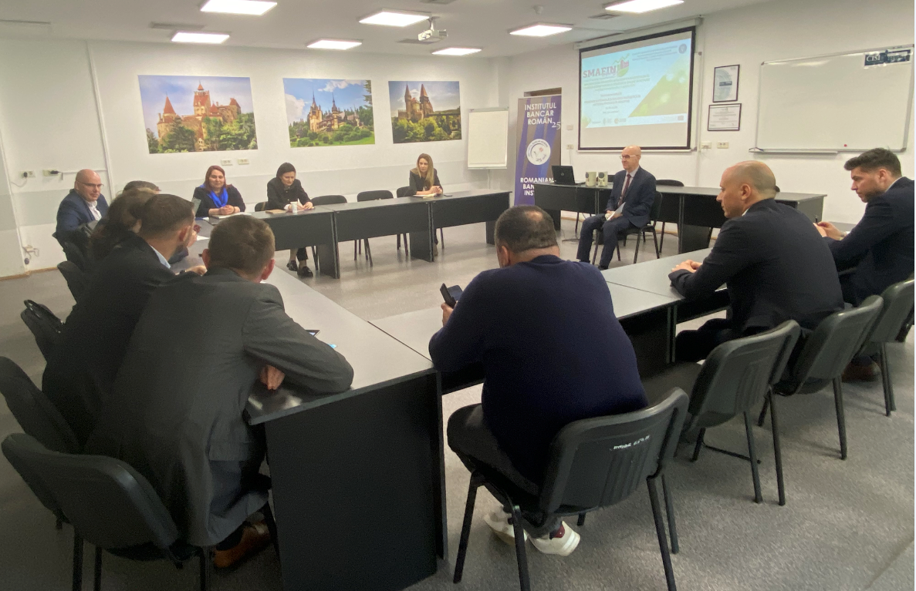
Figure 5: Image from Parallel Thematic Session 3

THE DEBATE FRAMEWORK AND FREE’S PRESENTATION
The third parallel session brought together representatives of financial institutions, employers’ associations and relevant organisations involved in promoting and financing energy efficiency in the tertiary and industrial sectors. The session began with an introduction by the moderator and a round of introductions by the participants.
The FREE representative presented the organisation’s profile and activities, emphasising that it funds any type of project aimed at energy efficiency in industry or in any energy-consuming process where savings can be made — technological equipment, lighting projects, the use of renewable sources to meet the energy needs of institutions or dependent systems, including local water management systems. FREE has an international dimension, having been a member of the Coalition for Energy Efficiency Financing since 2024 and part of several working groups organised at European Union level, including the Energy Investor Dialogue.
The institution has a statutory commitment to education and is involved in any initiatives that help to raise public awareness of the concept of energy efficiency. It has been noted that interest in funding energy efficiency projects rises significantly during periods of energy price crises — a primary barrier of a behavioural and educational nature, as a reactive approach is not the most reliable: well-structured energy efficiency projects are, by their very nature, sustainable, generating constant savings throughout their lifetime, regardless of price fluctuations. A second barrier identified concerns beneficiaries’ dependence on grants, particularly evident amongst industrial partners, who make the launch of investments conditional on access to non-repayable funding.

LIBRA INTERNET BANK
The representative of Libra Internet Bank — Coordinator of Agreements and Funding Programmes — expressed interest in the energy efficiency and sustainability component, which is present in all projects funded by the institution. The representative from FREE stated that the institution they represent is not authorised to apply for funding in the residential sector via the same platform, but only for public buildings.
The representative of the Ministry of Finance, Public-Private Partnership Directorate, expressed interest and a willingness to collaborate with the Ministry of Energy in the field of energy efficiency.

INVESTMENT AND DEVELOPMENT BANK (BID)
The BID representative, a Director within the Sustainable Development Directorate, stated that the institution is collaborating with the Ministry of Finance and all line ministries. For projects implemented by local or semi-public authorities, once the available funding ceiling has been exhausted, eligible projects are placed on a waiting list and, as budget adjustments are made, are funded in the order in which they were registered.
The institution’s history was outlined: the BID was established in November 2023 and commenced its actual operations in 2024, obtaining the status of a development bank in December 2024 upon its registration in the National Bank of Romania’s register of credit institutions. The institution currently offers three mature products on the market:
- A portfolio guarantee for SMEs, through which the BID collaborates with financial intermediaries — commercial banks and non-bank financial institutions — guaranteeing up to 80% of the value of an investment or working capital loan.
- An individual guarantee for local authorities, regional operators, municipal companies and their subsidiaries. The guarantee is provided to the commercial bank financing the project, facilitating access to finance, including for local authorities with projects that do not generate revenue.
- Direct funding from own resources for sustainable projects, with sustainability understood in its long-term financial sense.
In the case of energy efficiency projects implemented through project companies with their own economic activity, the local council may act as a guarantor, which allows access to distinct financing structures. It was firmly stated that the BID is not in competition with any commercial bank, its products being complementary to the existing offering. The BID monitors both institutions supervised by the National Bank of Romania and non-bank financial institutions.

THE NEW ENERGY SOURCES EMPLOYERS’ ASSOCIATION (SUNE)
The SUNE representative presented the history of the organisation, which was established in 2008 in response to the market conditions at that time. SUNE has expanded significantly, establishing clusters dedicated to its members and technology transfer centres in the fields of energy, the environment and information technology. The approach adopted was thematic, involving the development of specific projects through which strong relationships were built with specialists from the academic community.
Two relevant projects were presented in the field of waste-to-energy. The first focused on gasification technology and arose from the desire of a company with expertise in electrical solutions to expand its business by integrating a complementary technical component geared towards the utilisation of agricultural and forestry waste and biomass. The resulting project combined electricity generation with heat recovery and the production of biochar — a high-value-added form of plant-based charcoal.

MINISTRY OF ECONOMY, DIGITALISATION, ENTREPRENEURSHIP AND TOURISM (MEDAT)
The MEDAT representative presented the Start-Up Nation programme for SMEs, funded under the Education and Employment Operational Programme 2021–2027. The programme requires participants to complete, in advance, an entrepreneurship course of at least 40 hours, organised by 300–400 trainers, with an estimated 30,000–40,000 participants and a target of at least 7,500 funded projects. The non-repayable financial aid under the scheme is up to €50,000 per applicant, representing 90% cent of the total investment value, with a mandatory minimum own contribution of 10%. Projects in the manufacturing sector are given preference in the scoring system. The intention to continue the ‘Women Entrepreneurs’ programme’ in 2026 was mentioned.
The Ministry maintains ongoing contact with the business community through the Advisory Council for SME Development (CCDIMM), through which it disseminates information on European developments and opportunities to participate in trade fairs and economic missions, and collects proposals for legislative amendments.
The GEIEAN mechanism — the Group for the Assessment of the Economic Impact of Regulatory Acts on SMEs — was presented. Operating under Law 346/2004, this mechanism requires all institutions drafting regulatory acts that have an impact on SMEs or the business community to seek the opinion of the Ministry of Economy. The Ministry decides whether the SME Test needs to be applied, particularly when new administrative or fiscal burdens are introduced. The mandatory nature of this mechanism was reinforced by Government Emergency Ordinance 75/2025, adopted in December 2025. It has been noted that, in practice, numerous legislative amendments affecting the business environment have not undergone the SME Test procedure, as the process has been stalled at the Ministry of Justice.
As Chair of the Commission for the Authorisation and Accreditation of Business Incubators, the MEDAT representative outlined the legal framework — Law 102/2016 — noting that Romania is the only country to grant the official title of ‘business incubator’ by order of the central public authority. Business incubators take newly established companies under their wing, provided they are no more than three years old, supporting them through management assistance, access to infrastructure and shared services. There are currently 28 authorised business incubators operating in Romania .
The moderator pointed out that within the Multiregional Platform managed by the EIB, there is a dedicated funding line for business incubators, through which a financing package can be offered comprising a loan at near-zero interest, a performance-based grant and technical assistance throughout the implementation period.

COGEN ROMANIA PROFESSIONAL ASSOCIATION (COGEN)
The representative of COGEN Romania presented the organisation — a professional association established in 2003, comprising 48 members accounting for over 80% of energy production. The aim of the presentation was to highlight cogeneration as an essential pillar of Romania’s energy planning.
The process of electrification — in transport, buildings and the residential sector — is generating an ever-increasing demand for electricity, with direct implications for the grid infrastructure, an issue that has not been sufficiently communicated to the public. According to the 2024 Energy Policy Group report, the investment required in Romania’s electricity networks by 2030 is estimated at €6.8 billion for transmission networks and between €9.2 and €11.5 billion for distribution networks — sums needed solely to meet the climate targets that have been set. These figures do not include the additional impact of the widespread electrification of heating through heat pumps and electric systems, which would generate consumption peaks posing a real risk of overloading the grid.
Cogeneration has been presented as a complementary and efficient solution: it reduces the cost of heat production, provides heat and electricity locally, and enables energy to be produced exactly where it is needed during peak demand periods. Unlike the full electrification of heating, cogeneration allows for a balanced use of the energy infrastructure.
Under Directive 2024/1275/EU (EPBD), adopted in May 2024, the energy required by nZEB buildings must be met predominantly from renewable sources produced on-site or nearby, with cogeneration recognised as an eligible technology. Where the primary energy source is provided by an efficient District Heating System (DHS) with a high proportion of energy from high-efficiency cogeneration, the connected building may benefit from a more favourable primary energy factor.
In Romania, there have been two sources of funding for cogeneration projects — the National Recovery and Resilience Plan (PNRR) and the Modernisation Fund. Under the PNRR, two projects are currently being implemented, whilst two could not be put into practice (Chimcomplex and Electrocentrale Craiova SA). Under the Modernisation Fund, approximately 16 projects were submitted, with their total value exceeding the fund’s total budget by €2.1 billion— only three projects were awarded, all in Bucharest.
Under the Energy Efficiency Directive, all localities with fewer than 20,000 inhabitants are required to do a mapping of their heating and cooling systems, as well as local heating and cooling plans, with a view to achieving climate neutrality by 2050.

HOLCIM ROMANIA
A representative of Holcim Romania — part of one of the world’s leading producers of sustainable building materials, operating in Romania through cement plants in Câmpulung and Aleșd, concrete mixing plants, aggregates, special binders and cement terminals —, raised the issue of the deadline for transposing Directive (EU) 2023/1791 on energy efficiency into national law.

4ENVIGO
4ENVIGO is a Romanian company specialising in comprehensive solutions for the transition to renewable energy and energy efficiency, with over 16 years’ experience, offering integrated services ranging from consultancy on ESG strategy development to design, installation, operation and maintenance, with a portfolio of over 100,000 photovoltaic panels delivered and an installed capacity of over 30,000 MWh per year.
The 4ENVIGO representative highlighted a recent challenge for the photovoltaic sector — the entry into force in May 2025 of Standard P118/1-2025 on fire safety in buildings, which introduces strict restrictions on the installation of photovoltaic panels on roofs and stringent requirements regarding the fire resistance of materials. The regulation poses major difficulties for buildings with sandwich-panel roofs, as compliance costs may exceed the value of the photovoltaic system itself — calling into question the economic viability of photovoltaic projects on existing industrial roofs.
The company’s business model involves developing and selling projects to a specialist company — the investment owner — which subsequently makes them available to the end user via finance lease, operating lease or a PPA (Power Purchase Agreement). The moderator recommended adopting an EES (Energy Efficiency Service) model, similar to the ESCO model, whereby 4ENVIGO would make the investment from its own resources, offering the owner a share of the savings achieved and recouping its investment from the remaining savings generated. This mechanism would ensure a steady cash flow and enable broad categories of customers who lack the technical expertise or the necessary resources to implement energy efficiency measures themselves to access energy efficiency services.

CAR SERVICE
A representative from a car service centre outlined the company’s approach to energy efficiency — focused simultaneously on operational efficiency and development. The facility has a photovoltaic system that covers approximately 40% of its energy consumption during the warmer months, with this figure falling to 2–3% in winter. The main energy consumers are the paint booth and the oven, as well as the fleet of Tesla electric vehicles made available to customers, whose charging stations account for a significant additional consumption.

CLOSING PLENARY SESSION
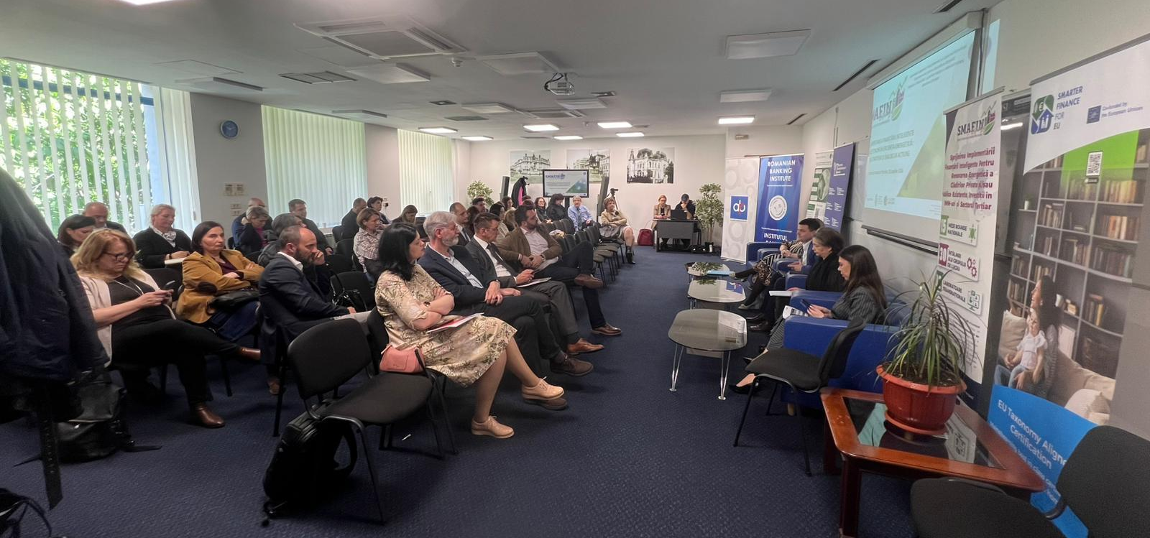
Figure 6: Image from the Closing Plenary Session – Reporting on the Parallel Thematic Sessions

The closing plenary session brought together all participants, with the moderator inviting the designated rapporteurs to present the conclusions of the parallel thematic sessions:
THE RAPPORTEUR FOR PARALLEL THEMATIC SESSION 1 — the representative of the Bucharest Stock Exchange — summarised the main conclusions arising from the discussions of the group, which brought together stakeholders supporting the process of improving energy efficiency through various financial instruments — loans granted by national and international banking institutions (BCR, EBRD, EIB), alongside the capital market as a complementary alternative:

- Stronger State Coordination: The state should play a more active coordinating role by creating a centralised platform that consolidates funding opportunities and relevant stakeholders, providing end users with clear and accessible information.
- Financing Needs and EU Targets: Achieving energy efficiency objectives will require an estimated €30 billion by 2030 and more than €100 billion by 2050. Given Romania’s low energy-efficiency performance, more realistic implementation timelines should be negotiated at EU level.
- Regulatory Framework: the NDBR is due to be available by the end of July. Existing regulations require a thorough review to ensure coherence and effectiveness. EU directives should be adapted to Romania’s implementation capacity rather than transposed mechanically.
- Education and Awareness: Long-term national awareness campaigns are essential to drive behavioural change. Successful international examples demonstrate that sustained efforts over several years are more effective than short-term initiatives.
- Available Financial Resources: Significant funding potential exists both domestically and internationally, including private savings in Romania and green bond financing that can attract institutional investors.
- Technical Assistance: End users need stronger support mechanisms to access European funds and other financing instruments.

Overall conclusion: an integrated approach is needed, with energy efficiency policies implemented through a coordinated approach that aligns effective regulation, financing, technical assistance, and long-term awareness-raising efforts.
THE RAPPORTEUR FOR PARALLEL THEMATIC SESSION 2 — the UTCB representative and Chair of the OAER — summarised the main conclusions of the debates, organising the contributions into several key areas:

At the outset, it was noted that, whilst discussions in earlier stages of the SMAFIN project had focused predominantly on mobilising financial resources, a paradigm shift is now required — moving from the question ‘how do we mobilise funds?’ to the question ‘how do we demonstrate, compare and scale up the results?’.

- The National Digital Building Register was the first and most comprehensive topic of the session. The platform, led by the MDLPA, is set to become operational on a pilot basis towards the end of the second quarter of 2026, based on the integration of data relating to buildings renovated under the PNRR. The Register is the tool that brings together in a single place the energy performance certificate, the renovation passport, project data, the source of funding and post-implementation results — the latter being a longer-term objective, as the project has a total duration of five years.

- Some contextual statistical data taken from the National Integrated Plan for Energy and Climate Change (PNIESC) were presented: buildings account for almost 42% of final energy consumption in Romania; at European level, 85%of buildings were constructed before 2000, and 75% have poor energy performance — figures which confirm that the renovation rate remains extremely low compared to the 3% target set out in European regulations. A shift is anticipated from a predominantly financial and political approach to energy efficiency towards the governance of implementation data — a credible system for collecting, monitoring and utilising data on the actual results of investments.

- Performance indicators were the second major topic. It was argued that monitoring should not be limited to the funds absorbed, but should focus on the actual energy savings achieved, the reduction in CO₂ equivalent emissions, the level of comfort in the renovated buildings and the quality of the work carried out. The discussion must shift from an isolated technical outcome to a verifiable technical and social outcome, correlated with the financial resources used.

- Integrated monitoring of funding programmes represented the third area of focus. Data from the European Commission’s March 2026 report was cited, showing that, through the Recovery and Resilience Programme, €650 billion was allocated at European level, of which approximately €104 billion was earmarked for investments in energy efficiency, whilst €79.4 billion was channelled into the buildings sector. As regards Romania, the RePowerEU initiative is supporting the renovation of 3.2 million square metres of block-of-flats and 2.3 million square metres of public buildings.

- Implementation bottlenecks were addressed in relation to the role of one-stop shops and technical assistance, with the conclusion being that a shift is needed from a conceptual framework to a permanent support mechanism for implementation.

- Reporting to funders — taxonomy, use of funds, bankability, data reliability — was merely touched upon during the discussions, without sufficient depth due to time constraints.

Overall conclusion: in the next phase, energy efficiency will no longer be important solely from a funding perspective, but will depend equally on the development of a credible infrastructure of data and indicators, enabling the quality of renovation and modernisation works to be verified, institutional support for transforming funded projects into measurable and bankable results, as well as comparing the effectiveness of various funding schemes.

THE RAPPORTEUR FOR PARALLEL THEMATIC SESSION 3 — the SUNE representative — summarised the main conclusions of the debates:

- the existence of programmes dedicated to SMEs managed by MEDAT — Start-Up Nation and Women Entrepreneurs — under which applications for project funding may also include an energy efficiency component;
- MEDAT works in close collaboration with CCDIMM and the Commission for the Implementation and Monitoring of Business Incubators and is present through the 28 operational incubators nationwide. The GEIEAN mechanism was also mentioned, through which the SME Test is applied to verify whether new regulations impose disproportionate administrative burdens on SMEs;
- the interest expressed by the Ministry of Finance in collaborating with the Ministry of Energy on the issue of funding for energy efficiency;
- BID, operational from 2024, complements the services offered by commercial banks, providing three main products: portfolio guarantees for SMEs of up to 80%, individual guarantees for local authorities and municipal companies, and direct financing for sustainable projects of a strategic nature;
- Cogeneration should be recognised as a pillar of energy planning in Romania, a proposal supported by COGEN Romania, which argues that, although the current trend favours electric heating, the financial barrier posed by the necessary investment in the electricity transmission and distribution system is difficult to overcome. Cogeneration leads to a reduction in process energy consumption, and new public buildings connected to an efficient, zero-emission district heating and cooling system (SACET) are considered nearly zero-energy buildings (ZEBs);
- the presence of 4ENVIGO, a company offering ESCO partnerships for the industrial sector — particularly to businesses where energy expenditure ranks among the top five operational costs (‘energy-intensive companies’) — represents a significant quantitative increase in ESCO services on the Romanian market;
- FREE presented its activities in areas such as cogeneration, trigeneration, waste-to-energy, the use of renewable energy sources by local public authorities, and the renovation of their buildings. FREE stands out amongst financiers in the sector for the rigour with which it approaches feasibility studies, rejecting projects that do not meet quality standards;
- SUNE presented research and development projects carried out through clusters and technology transfer centres, with results in the field of waste-to-energy.
- The main barriers underlined:
- behavioural and educational: energy efficiency is primarily considered by company managers during periods of rising energy prices, whilst the ongoing cost savings it generates are insufficiently understood and utilised;
- the security of the national energy grid: a technical barrier primarily caused by the age of the energy system.

Overall conclusion: users’ dependence on grants remains a significant obstacle to the development of a sustainable energy efficiency market as no form of dependence is beneficial in the long term.

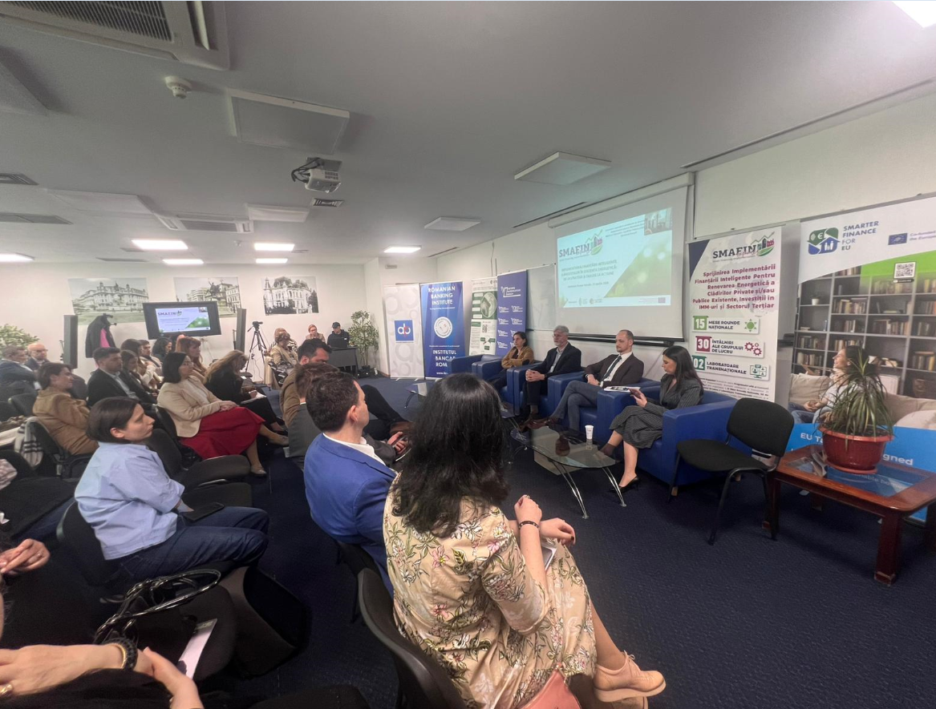
Figure 7: Image from the Closing Plenary Session – Conclusions and Next Steps

GENERAL CONCLUSIONS OF THE RT
Representatives from the pRO-nZEB and ROENEF clusters, alongside the representative from MDLPA, were invited to summarise the day’s general conclusions and outline the next steps.
The third SMAFIN Expanded RT confirmed that the transition from strategies and dialogue to action — the central theme of the event — is not merely an aspiration, but an urgent necessity, in the context of Romania’s commitments to the European Union regarding climate neutrality and energy efficiency.
1. Mobilising private capital: The financial resources required to meet energy renovation targets — €30 billion by 2030 and €100 billion by 2050 — far exceed the capacity of public funds, necessitating the mobilisation of private capital through combined financial instruments, green bond issues and blended finance mechanisms, complementing European funds. The European Energy Efficiency Finance Coalition and its National Hub provide the strategic framework through which this mobilisation can be put into practice.
2. Data infrastructure: Data infrastructure relating to the national building stock is an essential prerequisite for any credible and scalable financing initiative. The National Digital Building Register — currently being rolled out — provides the necessary foundation for demonstrating, comparing and scaling the results of energy efficiency investments, moving beyond mere financial reporting to the governance of implementation data.
3. Overcoming the dependence on grants: Excessive reliance on full grants and political factors in programme implementation is a structural barrier that must be overcome through a paradigm shift — at both the beneficiary and decision-maker levels. Combined financial instruments, performance-based grants and ESCO or EES models represent the way forward, whilst educating and raising awareness amongst end beneficiaries is a national priority requiring a sustained, long-term campaign.

4. Inter-institutional coordination: Inter-institutional coordination and the clarification of responsibilities amongst the ministries involved —MDLPA, Ministry of Energy and MIPE— remain unresolved challenges, the resolution of which depends on political will and the active involvement of all relevant stakeholders, including the private sector, international financial institutions and civil society, in dialogue formats such as that facilitated by SMAFIN Expanded.
5. Functional mechanisms for connecting supply and demand: Romania has the expertise, financial instruments and committed funders in the field of energy efficiency, but there is a lack of functional mechanisms for connecting supply with demand, aggregating projects at scale and monitoring actual results. The National Hub of the European Coalition for Energy Efficiency Financing serves as the platform through which the actions of these stakeholders can converge.
6. Recommendations for public policies:
- Recognising high-efficiency cogeneration as a pillar of national energy planning — developing a public policy framework that integrates cogeneration and efficient SACET systems into local and national decarbonisation strategies, harnessing their potential to reduce pressure on electricity grids and contribute to achieving nZEB targets;
- Digitisation and standardisation of energy efficiency data flows in the industrial and tertiary sectors — establishing clear requirements for reporting and verifying the actual results of funded projects, by integrating measured consumption data into national monitoring systems, as a basis for accessing green finance and for reporting in accordance with the requirements of the EU Taxonomy and the CSRD;
- Developing the green bond market in Romania as a complementary instrument for financing energy efficiency — developing a public policy framework to encourage the issuance of green bonds by local authorities, banking institutions and private companies, capitalising on the potential of household savings within the Romanian banking system and the capacity to attract international institutional investors.
These proposals, together with those identified during the project, will be discussed at the SMAFIN EXP working group’s forthcoming meetings so that the project team can include them in the package of proposals to be drawn up in support of smart financing for energy efficiency within the national context, in Romania.

NEXT STEPS AND PROJECT SUSTAINABILITY
The SMAFIN Expanded project will continue to be implemented until the end of September 2026, after which the results, methodology and dialogue developed within the project will be taken up and consolidated by the National Hub of the European Coalition for Energy Efficiency Financing.

The pRO-nZEB Cluster and ROENEF have entered into a cooperation agreement with the Ministry of Energy and will continue to support, alongside RoGBC, the efforts of the MDLPA. These initiatives aim to strengthen the strategic role of public institutions in mobilising financial instruments and fostering collaboration with relevant stakeholders in the financial, construction and related sectors. These efforts are intended to facilitate access to funding for energy efficiency projects in buildings, industry and the tertiary sector — which is essential for transforming dialogue into action and strategies into concrete, measurable results.

Document drawn up based on the official minutes of the third SMAFIN Expanded National RT held on 23 April 2026 in Bucharest.

Commission launches the European Housing Alliance – Housing, https://housing.ec.europa.eu/european-affordable-housing-plan_en
https://www.imm.gov.ro/incubatoare-de-afaceri/
• The long-term sustainability of GUEEs – contributing to the formulation of a set of guidelines to facilitate their business continuity, high-quality services and impactful actions for the energy transition. • Possible expansion/replication of the multi-regional investment platform managed by the EIB in Romania to include other national or international funding streams as an innovative strategic mechanism for better integration of financial resources. • Tailored solutions to tackle energy poverty in Romania and the diversification of targeted programmes, alongside the integration of public databases to better identify beneficiaries (not only household profiles, but also consumer profiles).

